# WOMEN SAFETY GADGET - SAFETY FIRST



### A PROJECT REPORT

***Submitted by***

### ABHIJNYA K.G (1BM18CS002)

### ANKITHA (1BM18CS016)

### DIVYAKRITI M (1BM16CS029)

***in partial fulfillment for the award of the degree of***

**BACHELOR OF ENGINEERING**

***in***

### COMPUTER SCIENCE AND ENGINEERING

***Under the Guidance of***

### Dr. UMADEVI V

**Associate Professor and HOD Dept of CSE, BMSCE**



### B. M. S. COLLEGE OF ENGINEERING

**(Autonomous Institution under VTU)**

### BENGALURU-560019 MAY 2020

**DEPARTMENT OF COMPUTER SCIENCE AND ENGINEERING**

**CERTIFICATE**

Certified that the project entitled “**WOMEN SAFETY GADGET - SAFETY FIRST**” is a bonafide work carried out by ABHIJNYA K.G (1BM18CS002), ANKITHA (1BM18CS016), Divyakirti Masaun (1BM18CS029) in partial fulfillment for the award of Bachelor of Engineering in Computer Science and Engineering of the Visvesvaraya Technological University, Belagavi during the academic year 2019 - 20. The project report has been approved as it satisfies the academic requirements in respect of project work prescribed for the said degree.

|  |  |
| --- | --- |
| **Guide**  **Dr. PALLAVI G.B,** Associate Professor, Dept of CSE,  B.M.S. College of Engineering | **Head of Department**  **Dr. JYOTHI S. NAYAK**,  Professor & HOD,  Dept of CSE,  B.M.S. College of Engineering |

#### Principal

**Dr. B. V. Ravishankar**

B.M.S. College of Engineering

External Viva

|  |  |
| --- | --- |
| Name of the Examiners | Signature with Date |
| 1. |  |
| 2. |  |

**Table of Contents**

|  |  |
| --- | --- |
| **TITLE** | **PAGE NO.** |
| **ABSTRACT** | **i** |
| **Declaration by the student batch and guide** | **ii** |
| **Acknowledgements** | **iii** |
| **LIST OF TABLES** | **iv** |
| **LIST OF FIGURES** | **v** |

|  |  |  |
| --- | --- | --- |
| **CHAPTER NO.** | **TITLE** | **PAGE NO.** |
| 1 | **Introduction** | 1 |
| 1.1 | Overview | 1 |
| 1.2 | Motivation | 2 |
| 1.3 | Objective | 2 |
| 1.4 | Scope | 3 |
| 1.5 | Existing System | 4 |
| 1.6 | Proposed System | 4 |
| 2 | **Literature Survey** | 6 |
| 2.1 | Deep Learning models | 7 |
| 3 | **Software and Hardware Requirement Specification** | 8 |
| 3.1 | Functional Requirements | 8 |
| 3.2 | Non-functional Requirements | 8 |
| 3.3 | Hardware Requirements | 9 |
| 3.4 | Software Requirements | 9 |
| 3.5 | Cost Estimation | 10 |
| 4 | **Design** | 11 |
| 4.1 | High Level Design | 11 |
| 4.2 | System Architecture | 13 |
| 4.3 | Use-case Diagram | 15 |
| 4.4 | Class Diagram | 16 |
| 4.5 | Sequence Diagram | 17 |
| 5 | **Implementation** | 18 |
| 5.1 | Overview of Technologies Used | 18 |
| 5.2 | Implementation details of modules | 19 |
| 5.3 | Difficulties encountered and Strategies used to tackle | 21 |
| 6 | **Testing and Experimental Analysis and Results** | 22 |
| 6.1 | Unit Testing | 22 |
| 6.2 | Integration Testing | 22 |
| 6.5 | Experimental Dataset | 24 |
| 7 | **Conclusion and Future Enhancements** | 26 |

|  |  |  |
| --- | --- | --- |
| 7.1 | Conclusion | 26 |
| 7.2 | Future Enhancements | 26 |
|  | REFERENCES | 27 |
|  | APPENDIX A: Snapshots | 29 |
|  | APPENDIX B: Details of list of publications related to  this project | 31 |
|  | APENDIX C: Details of patents | 32 |
|  | APENDIX D: Details of funding | 32 |
|  | APENDIX E: POs Mapped | 33 |
|  | APENDIX F: Plagiarism report | 34 |

### Abstract

Women have experienced all aspects of life, from grandeur and respect during the Vedic period to denial and servitude during the post-Vedic period. They even fought for the modern-day struggle for equality, acknowledgment, and existence. Violence, physical abuse, denial of the right to life, subordination, and neglect have all been perpetrated against women. Eve-teasing, molestation, sexual assault, and rape are examples of abuses that are frequently referred to as sexual harassment or sexual misbehaviour.

The evidence is all around us; women's voices are increasingly being heard in Parliament, the courts, and on the streets. From the beginning, India's Constitution granted women equal rights to males. Unfortunately, owing to illiteracy and restrictive traditions, most women in this country are uninformed of their rights. In India, there have been around 32000 murders, 19,000 rapes, 7500 dowry deaths, and 36500 molestation instances registered against women, and these are the approximate numbers, which are rising by the day. And these are only the incidents that have been recorded; most rapes and molestation crimes go unreported owing to the risk of losing family reputation in the society.

**DECLARATION**

We, hereby declare that the dissertation work entitled **“WOMEN SAFETY GADGET - SAFETY FIRST”** is a bonafide work and has been carried out by us under the guidance of Dr.Pallavi G.B**,** Associate Professor, Department of Computer Science and Engineering, B.M.S. College of Engineering, Bengaluru**,** in partial fulfillment of the requirements of the degree of Bachelor of Engineering in Computer Science and Engineering of Visvesvaraya Technological University, Belagavi.

I further declare that, to the best of my knowledge and belief, this project has not been submitted either in part or in full to any other university for the award of any degree.

Candidate details:

|  |  |  |  |
| --- | --- | --- | --- |
| SL.  NO. | Student Name | USN | Student’s Signature |
| 1 | Abhijnya K.G | 1BM18CS002 |  |
| 2 | Ankitha | 1BM18CS016 |  |
| 3 | Divyakriti M | 1BM16CS029 |  |

Place: Bengaluru Date:

Certified that these candidates are students of the Computer Science and Engineering Department of B.M.S. College of Engineering. They have carried out the project work titled “Women safety gadget - Safety first” as the final year (7th and 8th Semester) dissertation project. It is in partial fulfillment for completing the requirement for the award of B.E. degree by VTU. The works are original and duly certify the same.

|  |  |
| --- | --- |
| Guide Name  Dr. Pallavi G.B | Signature |

Date

### Acknowledgment

The authors would like to thank **Dr. JYOTHI S. NAYAK,** Professor and HOD, Department of CSE, B.M.S College of Engineering who provided precious insights and guided us along the entire process. She has been a beacon of light and a source of inspiration throughout the development of the project.

### List of tables

|  |  |  |
| --- | --- | --- |
| Table No. | Description | Page No. |
| 1 | Cost Estimation of the proposed system | 10 |
| 2 | Output classes | 23 |

**List of figures**

|  |  |  |
| --- | --- | --- |
| Figure No. | Description | Page No. |
| 1 | Graph indicating that the survey was conducted all over the country | 1 |
| 2 | Graph showing the range of people ages whose response has been recorded | 4 |
| 3 | Percentage of people voted for an women safety app | 11 |
| 4 | Percentage of people voted for an women safety IOT device | 12 |
| 5 | High Level Design | 13 |
| 6 | System Architecture of the proposed system | 13 |
| 7 | Use Case Diagram | 14 |
| 8 | Class diagram | 15 |
| 9 | Sequence Diagram | 16 |
| 10 | Train and test dataset splitting | 17 |
| 11 | Algorithm accuracy rate | 24 |
| 12 | Flow diagram of LCD display | 25 |
| 13 | Hardware component |  |
| 14 | Performance analysis |  |
| 15 | Different output class present in dataset |  |
| 16 | Temperature in the dataset |  |

**Chapter 1**

# Introduction

**1.1 Overview:**

Today in the current global scenario, the prime question in every girl’s mind, considering the ever-rising increase of issues on women harassment in the recent past, is mostly about her safety and security. The only thought haunting every girl is when they will be able to move freely on the streets even in odd hours without worrying about their security. This paper suggests a new perspective to use technology for women safety. “848 Indian Women Are Harassed, Raped, Killed Every Day!!” That’s way beyond a HUGE number! We propose an idea which changes the way everyone thinks about women safety. A day when the media broadcasts more of women’s achievements rather than harassment, it’s a feat achieved! Since we (humans) can’t respond aptly in critical situations, the need for a device which automatically senses and rescues the victim is the venture of our idea in this paper. We propose to have a device which is the integration of multiple devices, hardware consisting of a wearable “Smart band” which continuously communicates with Smartphones that have access to the internet. The application is programmed and loaded with all the required data which includes Human behavior and reactions to different situations like anger, fear and anxiety. This generates a signal which is transmitted to the smartphone. The software or application has access to Messaging services which are pre-programmed in such a way that whenever it receives an emergency signal, it can send help requests along with the location coordinates to the nearest Police station, relatives and the people in the near radius who have application. This action enables help instantaneously from the Public in the near radius who can reach the victim with great accuracy.

**1.2 Motivation**

Our project focuses on a security system that is designed merely to serve the purpose of providing security to women so that they never feel helpless while facing such social challenges. An advanced system can be built that can detect the location of a person that will enable us to take action accordingly based on electronic gadgets like GSM, Accelerometer sensor. We can make use of a number of sensors to precisely detect the real time situation of the women in critical abusive situations. The gadgets help make decisions along with other sensors like Accelerometer sensors to detect the abnormal motion of the women while she is victimized. The idea to develop a smart device for women is that it’s completely comfortable and easy to use as compared with already existing women security solutions such as a separate garment, bulky belts and infamous mobile apps that are just very abstract and obsolete. The Smart band integrated with Smart phone has an added advantage so as to reduce the cost of the device and also in reduced size.

**1.3 Objective:**

The device communicates with a laptop through a specially designed program that acts as an interface between the device and the laptop. The data directed by the smart band such as the pulse rate, temperature of the body along with the motion of the body is continuously monitored. In cases of abuse, the laptop directs the device to perform the following tasks:

* Send messages to the family members along with the coordinates.
* Also sends information to people in the near vicinity requesting public attention.

**1.4 Scope:**

The proposed design will deal with critical issues faced by women in the near past and will help to solve them with technologically sound equipment and ideas. This system can overcome the fear that scares every woman in the country about her safety and security.

**1.5 Existing System**

Having this concern in mind many developers have come up with creative applications. Some of such applications are: Codes like *91# is used to provide emergency services, which will alert police control. Free mobile application 'Help me on mobile' to ensure safety of women was launched to assist those who need emergency care. These applications need a single click to do this task. But when a girl is in trouble, there can be times that the girl is not capable of taking the phone and pressing the button.

**1.6 Proposed System**

The device communicates with a laptop through a specially designed program that acts as an interface between the device and the laptop. The data directed by the smart band such as the pulse rate, temperature of the body along with the motion of the body is continuously monitored. In cases of abuse, the laptop directs the device to perform the following tasks:

* Send messages to the family members along with the coordinates.
* Also sends information to people in the near vicinity requesting public attention.

**Chapter 2**

# Literature Survey

* + 1. Shaista Khanam, Trupti Shah proposed an algorithm for women safety using the fingerprint module. This paper gives a detailed approach towards women safety. Here fingerprint is required for activation of device, electric shock producing circuit, GSM and GPS module for alerting and location tracking. At the time of emergency, it is hard to place the finger in the fingerprint module and recognition is not possible, if there is any undesired stuff (wet or dust) in the finger. To avoid this problem the fingerprint module will not be used in the proposed system.
    2. My Safety Pin Mobile Phone Application: The limitations after the analysis was made were the app was unable to track the right location. Non functioning of the app in certain locations of India. Inconvenient user interface.
    3. Naeemul Islam, Md. Anisuzzaman, Sikder Sunbeam Islam, Mohammed Rabiul Hossain, Abuja far Mohammad Obaidullah developed a device for safety and protection of women. Here three push buttons are implemented to define the types of accident victims are facing. To control a whole system a PIC16F887A microcontroller is used. Since it is a 40 pin IC, it increases the size of the device, which will make it difficult for women/children to carry all the time.
    4. Sharifa Rania Mahmud, Jannatul Maowa, Ferry Wahyu Wibowo proposed an algorithm for women empowerment. This paper discusses about violence against women and also different health issues of women. It is an application-based system. During the event of molestation using the application present in the victim’s smartphone will automatically send out an emergency call to the assigned contacts. This can be done only when GPS is enabled in the smartphone and if not the time delay taken to turn on the GPS is noted to be the downside of the project.
    5. Anand Jatti, Madhvi Kannan, Alisha RM, Vijayalakshmi P, Shrestha Sinha developed a wearable device, which uses physiological signals like galvanic skin resistance and body temperature. Data is monitored using a cloud platform and analyzed using MATLAB simultaneously. If there is any sudden change in the physiological parameter, intimation will be sent to the parents. But body temperature may also change due to some other reasons. So, it is not fair to consider body temperature as a parameter to design a device for women's safety.
    6. Sunil K Punjabi, Suvarna Chair, Ujwala Ravale, Deepti Reddy developed an intelligent system for women and children. In this system they are using a pressure switch. When they feel unsafe, she has to compress the switch, then an intimation will be sent to parents followed by a call. If it is unanswered the call will be redirected to a nearby police station.
    7. M. Kavitha, V. Siva Chidambaranathan proposed a device for women self-protection using IoT. In this system there are few bio sensors used to sense the user’s bodily changes. If there are any abnormalities detected on women an intimation will be sent to the guardian as per preprogram of the device.
    8. R. Pavithra, S. Karthikeyan developed a survey on women’s safety mobile application. This application helps women to discover and help them in any critical situations. It helps find out the exact area of the individual and send SMS to the parents.
    9. Madhura Mahajan, KTV Reddy, Manita Rajput designed a rescue system for the safety of women. It is a simpler safety solution that can be achieved by pressing a switch and instantly sending out alerts to the near ones of the individual.

Following are the snapshots of the survey conducted by us. The responses for the survey were received from women across India and the age group of 17-60.

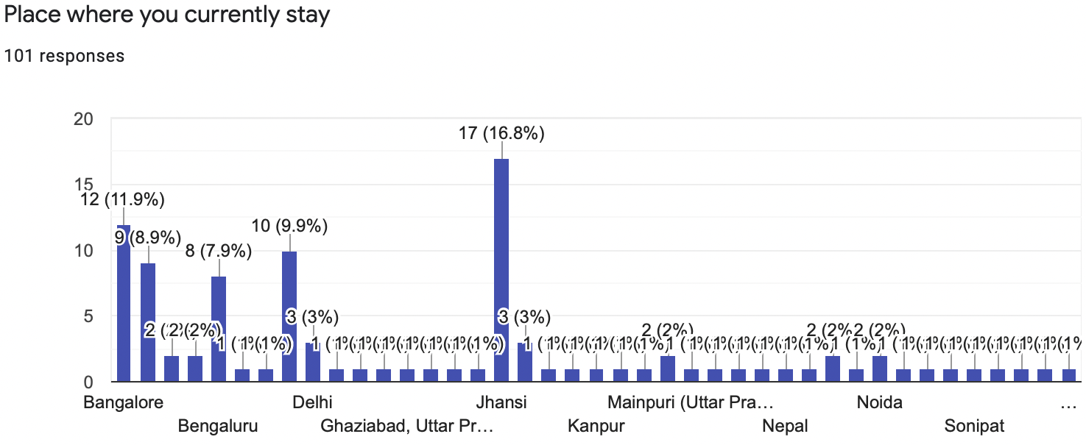

**Fig 1: Graph indicating that the survey was conducted all over the country**

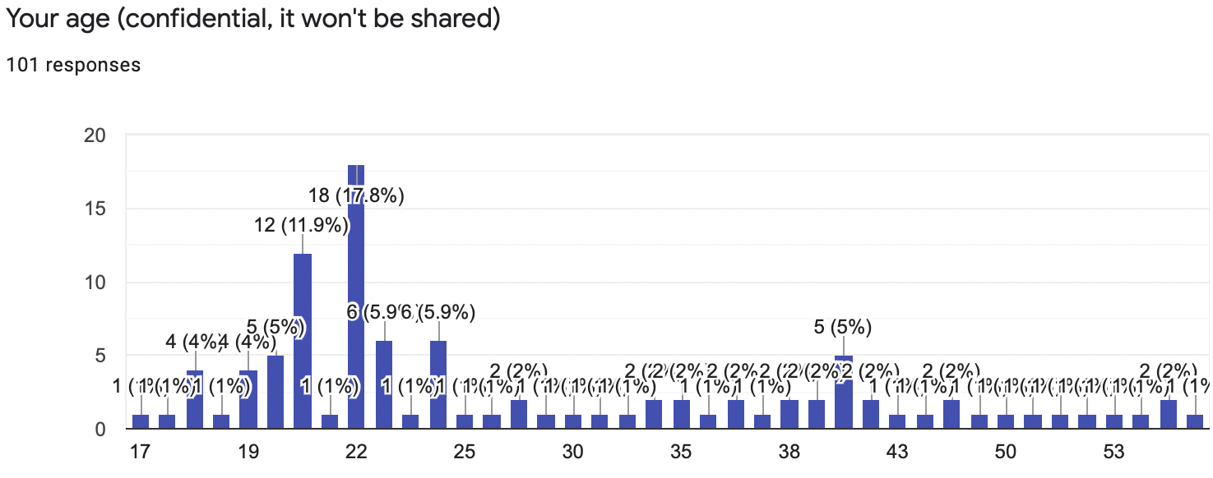

**Fig 2:Graph showing range of people ages whose response has been recorded**

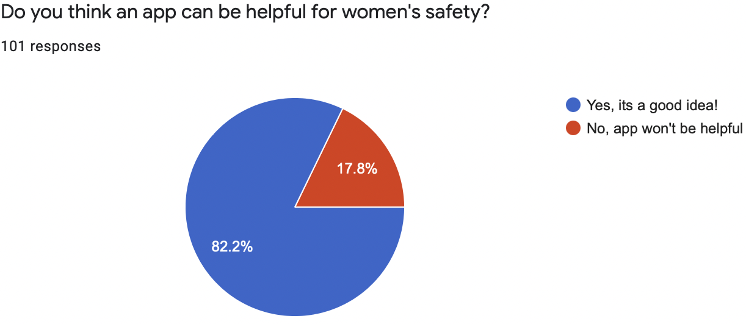

**Fig. 3: Percentage of people voted for an women safety app**

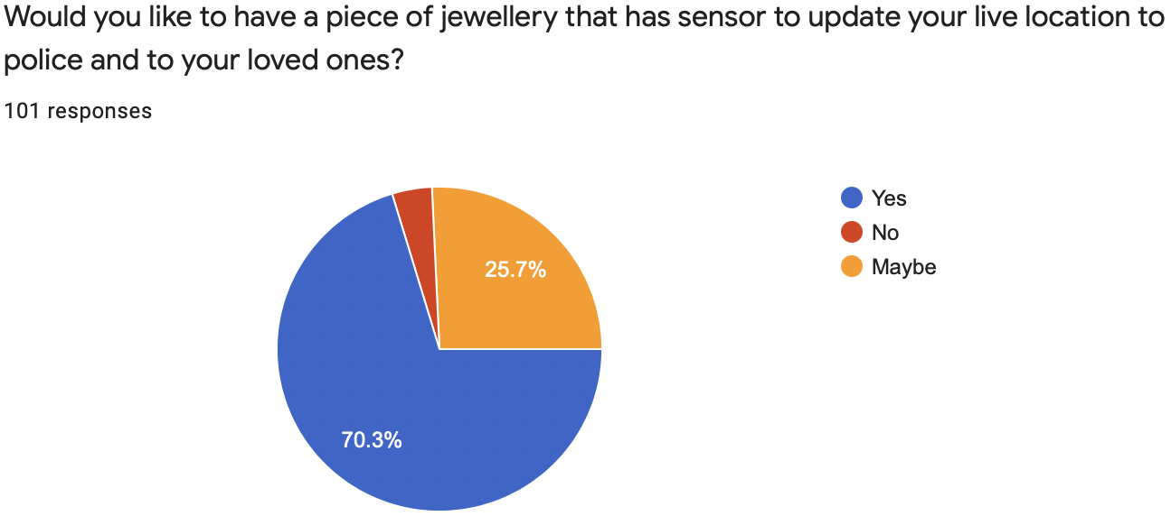

**Fig. 4: Percentage of people voted for an women safety IOT device**

**Chapter 3**

# Software and Hardware Requirement Specification

### Functional Requirement

A prototype module will be developed that includes LCD, GSM, GPS, accelerometer sensor and buzzer connected using Renesas 64 pin microcontroller. GSM is used to send SMS.

* Sensors able to record data correctly and process it.
* Microcontroller collects data from the sensors and process it in accordance with the code dumped, and display using the LCD display on the device
* In case of danger, alert messages should be sent to the required number along with the correct location, and also create some noise.
* The real time data collected by the microcontroller is sent to the python processing unit which predicts the panic state.

### Non-functional Requirements

Non functional requirements, as the name suggests, are requirements that are not directly concerned with the specific functions delivered by the system. They may relate to emergent system properties such as reliability, response time and store occupancy. Alternatively, they may define constraints on the system such as capabilities of I/O devices and the data representations used in system interfaces. The non functional requirements are as follows :

* **Efficiency**

Efficiency describes the extent to which time or effort is well used for the intended task or purpose. It is often used with the specific purpose of relaying the capability of a specific application of effort to produce a specific outcome effectively with a minimum amount or quantity of waste, expense, or unnecessary effort. "Efficiency" has widely varying meanings in different disciplines.

* **Scalability**

Scalability, as a property of systems, is generally difficult to define and in any particular case it is necessary to define the specific requirements for scalability on those dimensions that are deemed important. It is a highly significant issue in electronics systems, databases, routers, and networking. A system, whose performance improves after adding hardware, proportionally to the capacity added, is said to be a scalable system.

* **Interoperability**

Interoperability is a property referring to the ability of diverse systems and organizations to work together (inter-operate). The term is often used in a technical systems engineering sense, or alternatively in a broad sense, taking into account social, political, and organizational factors that impact system to system performance.

* **Reliability**

Reliability is the ability of a person or system to perform and maintain its functions in routine circumstances, as well as hostile or unexpected circumstances.

* **Usability**

The extent to which a product can be used by specified users to achieve specific goals with effectiveness, efficiency, and satisfaction in a specified context of use. The word usability also refers to methods for improving ease-of-use during the design process.

### Hardware Requirements

* Renesas microcontroller ( RL78 series )
* Panic Switch
* LCD
* GSM
* Accelerometer
* Alarm
* Heart rate sensor
* Temperature sensor

### Software Requirements

* CubeSutie+
* Renesas Flash Programmer
* Python (Idle/Jupyter notebook)

### Cost Estimation

Our cost breakdown structure as shown in the following table:

**Table 1. Cost Estimation of the proposed system**

|  |  |
| --- | --- |
| Renesas Microcontroller Board | 1150/- |
| LCD Display | 150/- |
| Power Supply Adaptor | 200/- |
| Accelerometer Sensor | 500/- |
| Switches | 300/- |
| Buzzer | 150/- |
| Temperature Sensor | 800/- |
| Heart rate sensor | 1500 |
| USB-TTL UART Module | 100 |

Total Cost Estimated = Rs. 4,850/-

**Chapter 4**

# Design

### High Level Design

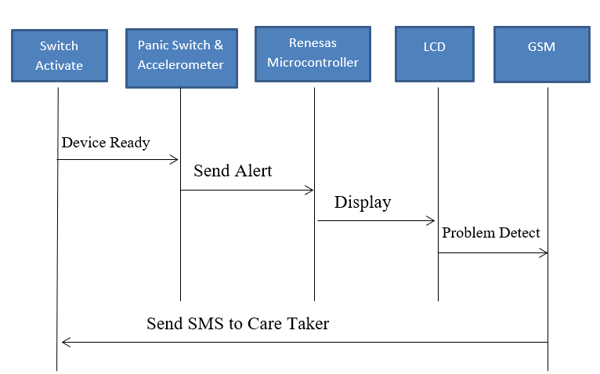

**Fig 5. High Level Design**

The complete system is mainly about safeguarding the women. The input to the whole system is sensed by the device, the inputs are the state of the panic button, accelerometer vibration, body temperature and heart beat rate. All of these are processed and by the device and machine learning is applied. And the output is if the person is in danger or safe or has had some health issues. Accordings message has to be sent.

#### System Architecture

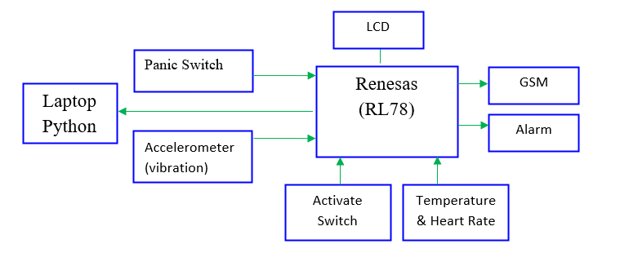

**Fig 6. System Architecture of the proposed system**

Systems can be divided mainly into two subsystems. The hardware device is used by the user mainly for sensing and processing. Renesas microcontroller is used. And the other part is the machine learning processing which uses two main algorithms: logistic regression and KNN.

#### Use -case Diagram

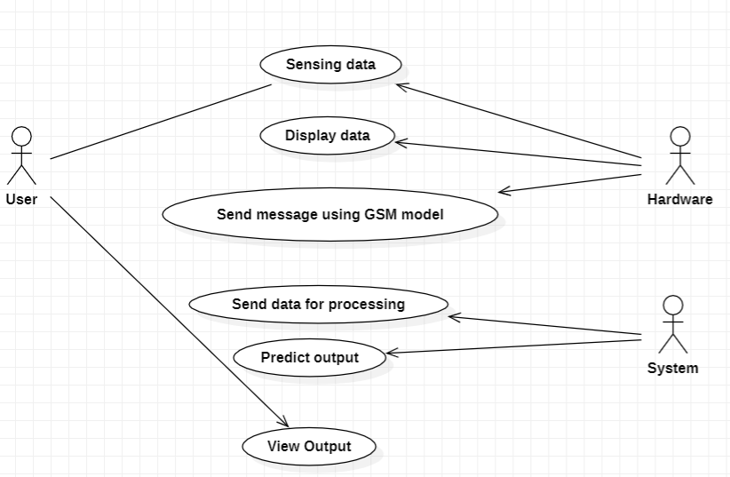

**Fig 7. Use Case Diagram**

Use case diagram has 3 main actors :

1. The user of the device : The user is the main actor who provides input to the device, he can perform actions like setting the panic switch, and other inputs are senses for them.
2. The hardware system: The hardware performs action like sensing data, and after processing displaying it and sending data to required contact.
3. The system : Receive data and process it. And gives the prediction

#### Class Diagram

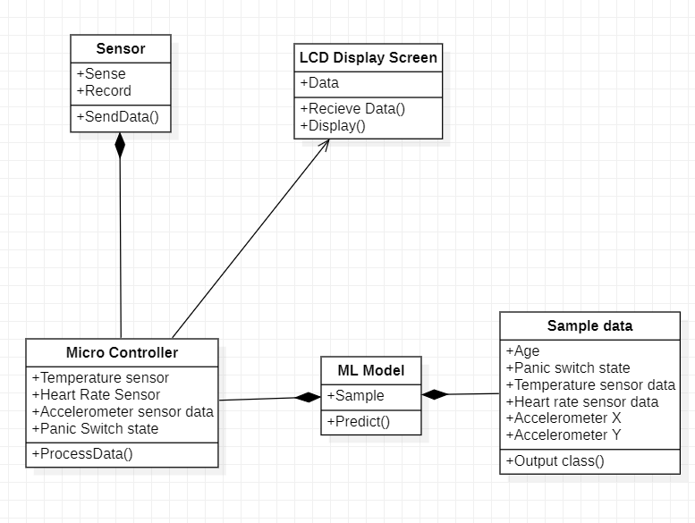

**Fig 8. Class Diagram**

There are following classes

* Sesors : sensing parameter and data record are the parameters and, sending data is the operation it performs.
* LCD display: has the data which has to be displayed. receiving data and displaying it are the operations of it.
* Microcontroller : main class which has all the data sent and processes it.
* ML - model: receives the data and predicting the result is its operation.

* + 1. **Sequence Diagram**

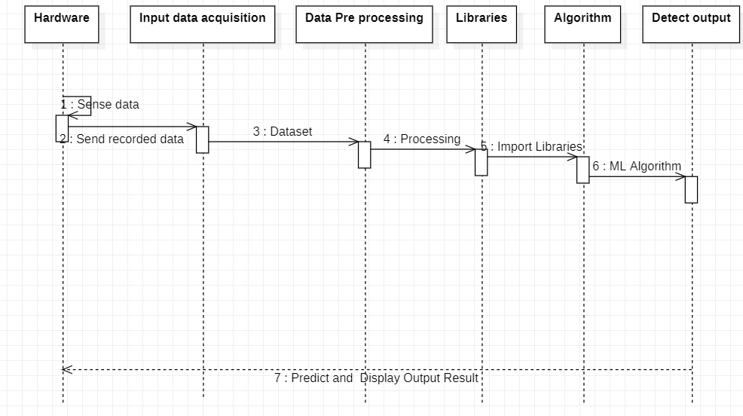

**Fig 9: Sequence diagram**

Hardware senses the data, which forms the input to the device, which is processed by the algorithm and output is predicted and sent using GSM module.

**Chapter 5**

# Implementation

### Overview of Technologies Used

Technologies used include:

* + - **Python**: Python is a dynamic language which is interpreted line by line and not compiled. Python is a strongly typed language and high-level language which makes it easy to understand. It supports object-oriented programming, functional programming and procedural programming. Python is especially preferred for implementing machine learning projects since it supports a variety of popular machine learning libraries like TensorFlow, matplotlib, sklearn, surprise, pandas, numpy, all of which were used to implement this project.
    - **Renesas Microcontroller:** The figure 3 shows the R5F100LEA microcontroller from Renesas RL78 series which is a 16-bit microcontroller used to implement this project. Microcontroller acts as the heart of the project, which controls the whole system. It contains of Flash ROM 64KB, RAM 4KB and Data Flash 4KB, and it has High speed on-chip oscillator, Self-reprogrammable under software control, 58 GPIO’s, 3 UART’s, Simplified I2C, 10 bit resolution ADC, 28 Interrupt Sources, ISP programming support etc.
* **Embedded C** is a set of language extensions for the C programming language by the C Standards Committee to address commonality issues that exist between C extensions for different embedded systems. Embedded C programming typically requires nonstandard extensions to the C language in order to support enhanced microprocessor features such as fixed-point arithmetic, multiple distinct memory banks, and basic I/O operations.
* **Pandas**: pandas is a software library written for the Python programming language for data manipulation and analysis. In particular, it offers data structures and operations for manipulating numerical tables and time series.
* **PySerial** is a library which provides support for serial connections ("RS-232") over a variety of different devices: old-style serial ports, Bluetooth dongles, infra-red ports, and so on. It also supports remote serial ports via RFC 2217 With the **xlrd** and **xlwt** Python Addon libraries you can easily read and write directly to Excel files.

**5.2 Implementation details of module**

* + 1. Prediction System
       - Preparing the dataset

We have prepared the data set for determining the state of the user using the device depending on certain parameters. The parameters considered for the data set are as follows

1. Accelerometer reading of X axis
2. Accelerometer reading of Y axis
3. Temperature
4. Heart rate
5. Panic switch state

The output classes for this dataset are:

1. 0 - Problem detected
2. 1 - Person is safe
3. 2 - Problem detected along with health issue detected
   * + - Building Model:

We mainly used two algorithms for the prediction.

KNN:K-nearest neighbors (KNN) algorithm uses ‘feature similarity’ to predict the values of new data points which further means that the new data point will be assigned a value based on how closely it matches the points in the training set.

Logistic regression: Logistic regression is a process of modeling the probability of a discrete outcome given an input variable.

We made use of Python libraries such as PySerial, xlrd, xlwt, numpy, matplotlib, seaborn, scikit learn, pandas etc

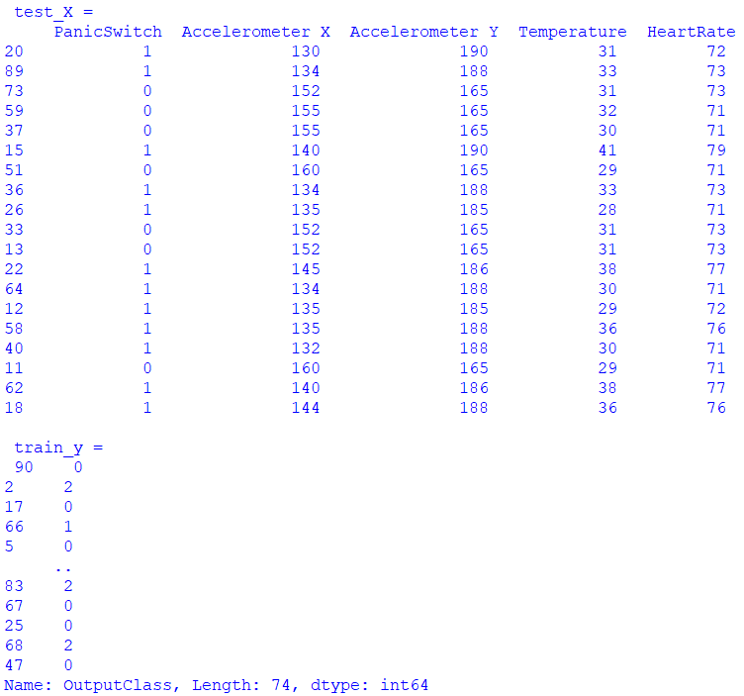

**Fig 10: Train and test dataset splitting**

* + - * Testing the model

We have used two algorithms: KNN and Logistic regression. As we can see in the figure the accuracy of both the algorithms is 94 percent.

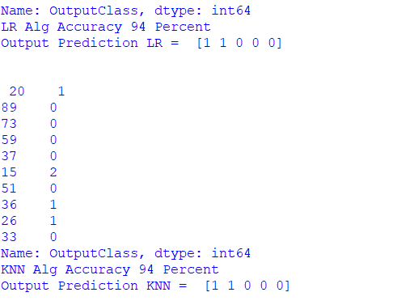

**Fig 11: Algorithm accuracy rate**

* + 1. Hardware implementation

We collected and organized all the required hardware components which includes the Reneses microcontroller, heart rate sensor, accelerometer sensor, LCD display, etc. Embedded C was used for the programming, which was written with the help of cubesuite software and dumped the code into the microcontroller with the help of Renesas Flash Programmer.

Renesas microcontroller: R5F100LEA microcontroller from Renesas RL78 series which is a 16-bit microcontroller is used to implement this project. Microcontroller acts as the heart of the project, which controls the whole system.

Accelerometer: Accelerometer is an electromechanical device that measures the force of acceleration due to gravity in g unit. It can be used in applications requiring tilt sensing. The ADXL335 measures acceleration along X, Y and Z axes and gives analog voltage output proportional to the acceleration along these 3 axes. Microcontrollers can process these voltages by converting them to digital signals using ADC.

LCD display:

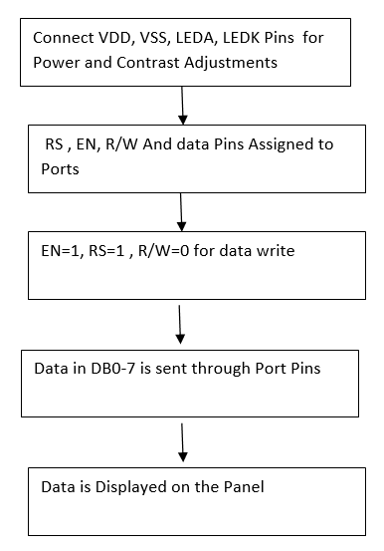

**Fig 12: Flow diagram of LCD display**

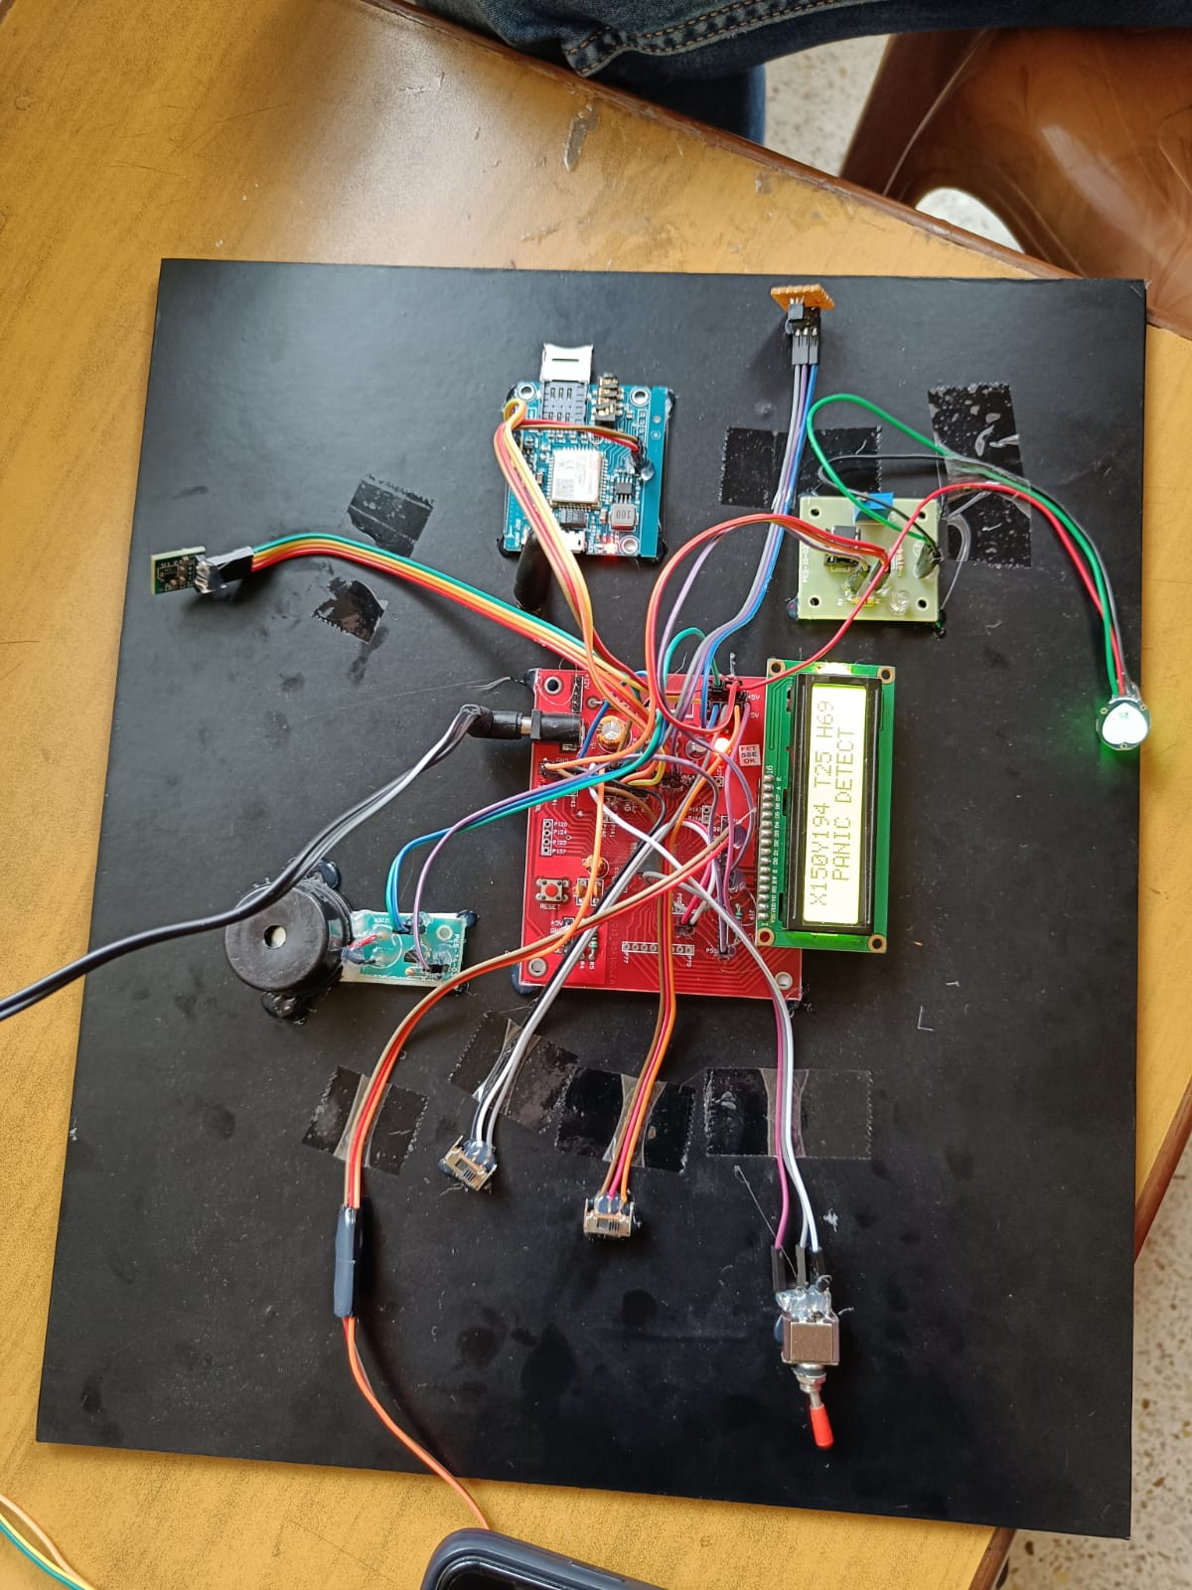

**Fig 13: Hardware component**

* + 1. Collection of real time data from hardware

USB-TTL UART Module-CP2102: This module helps all those who are comfortable with RS232/Serial Communication protocol, to build USB devices very easily. This module can be used with Laptops which don't have a standard serial port. This module creates a virtual COM port using USB on your computer which can support various standard Baud Rates for serial communication.

**5.3 Difficulties encountered and Strategies used to tackle**

We couldn't find the dataset for the problem statement, that is relating heart rate and panic state. We created our own dataset to encounter the problem. Sending the real time data from the hardware system for processing was a challenge. We used a powerful tool called UART-TTL converted and wrote the logic for it.

**Chapter 6**

# Testing and Results

### Unit Testing

Unit testing involves testing the various modules present in a software and hardware components. This is done to ensure that each module performs as expected and does not produce incorrect or unexpected results. We tested each of the hardware devices like the heart beat sensor, temperature sensor is working properly and gives right results. And the software modules include the one which predicts the output and one which collects real time data from hardware. All the modules executed successfully with no errors. We also tested the code written in embedded C which was dumped later to the device which ran successfully.

### Integration Testing

Integration tests are designed to test integrated software components to determine if they actually run as one program. Testing is event driven and is more concerned with the basic outcome of screens or fields. Integration tests demonstrate that although the components were individually satisfactory, as shown by successfully unit testing, the combination of components is correct and consistent. Integration testing is specifically aimed at exposing the problems that arise from the combination of components.

We made the connection of all components to make the device, and the whole hardware system worked successfully. The code which was written in python worked successfully as a whole.

### System Testing

After the integration testing phase, the software and hardware are integrated into a complete system and tested. We connected the hardware and the software code which successfully collected data from hardware and predicted the output as required.

### Evaluation Metric and Performance Analysis

The prediction model was built mainly using two algorithms Logistic regression and KNN. As we can see in the figure the accuracy of both the algorithms is 94 percent.



**Fig 14: Performance analysis**

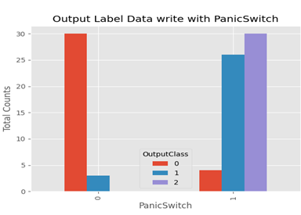

**Fig 15: Different output class present in dataset**

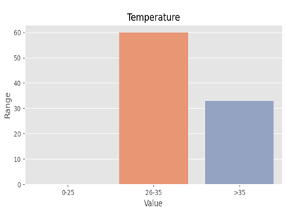

**Fig 16: The temperature range in the dataset.**

### Experimental Dataset

The device communicates with a laptop through a specially designed program that acts as an interface between the device and the laptop. The data directed by the smart band such as the pulse rate, temperature of the body along with the motion of the body is continuously monitored. When the switch is activated, the data will be collected from the device and recorded in the dataset. Hence, we will be using a real-time dataset for the prediction of the output. In cases of abuse, the laptop directs the device to do the following tasks:

* Send messages to the family members along with the coordinates.
* Also sends information to people in the near vicinity requesting public attention.

|  |  |  |  |  |  |
| --- | --- | --- | --- | --- | --- |
| Panic Switch | Accelerometer  X axis | Accelerometer  Y axis | Temperature | Heart Rate | Output Class |
| ON 1 | <140 | >185 | 25 to 35 | 70 to 75 | 0(Problem detected) |
| OFF 0 | 160 | 170 | 25 to 35 | 70 to 75 | 1 (No problem) |
| ON 1 | <145 | >180 | >35 | 76 to 80 | 2 (Problem detected along with health issue) |

**Table 2. Output classes**

**Chapter 7**

# Conclusion and Future Enhancements

**7.1 Conclusion:**

This type of an idea being the first of its kind plays a crucial role towards ensuring Women Safety in the fastest way possible automatically. The proposed design will deal with critical issues faced by women in the recent past and will help solve them through technologically sound gadgets. With further research and innovation, this project can be implemented in different areas of security and surveillance. The system can perform the real time monitoring of desired areas and detect the violence with a good accuracy.

**7.2 Future Enhancement:**

With further research and innovation, this project can be implemented in different areas of security and surveillance. The system can perform the real time monitoring of desired areas and detect the violence with a good accuracy.

**References**

[1] A STUDY ON SEXUAL HARASSMENT ON WOMEN IN INDIA by Madhu Balaaji  and S. Malaimagal.

<https://journalijcar.org/issues/study-sexual-harassment-women-india>

[2] Women’s Safety and Tracking System with GSM AND GPS Atharv Parbalkar, Shwetambari Belote , Shreyas Dharyekar , Amol Dhanawade , Heena Pyare

<https://www.academia.edu/52290528/Womens_Safety_and_Tracking_System_with_GSM_AND_GPS>

[3] Women’s Perceptions of Safety After Domestic Violence: Exploring Experiences of a Safety Contact Program Tania Westwood , Sarah Wendt and Kate Seymour

<https://doi.org/10.1177/0886109919873904>

[4] Women safety device and application-FEMME Article  in  Indian Journal of Science and Technology

<https://www.researchgate.net/publication/299404936>

[5] WOMEN SAFETY DEVICE BASED ON “INTERNET OF THINGS (IOT)” Urmilla Pilania ,Aishwarya Nair,Sakshi Arora,Virender Kadian Department of CSE , Manav Rachna University, Faridabad, Harayana, India

<https://www.jetir.org/papers/JETIRA006152.pdf>

[6] AbhijitParadkar, Deepak Sharma, All in one Intelligent Safety for Women Security, Department of ME, K.J.SomaiyaColege of Engg, Mumbai, India, Volume 130- No.11

<https://www.ijcaonline.org/research/volume130/number11/paradkar-2015-ijca-907144.pdf>

[7] My Safetipin Mobile Phone Application: Case Study of E-Participation Platform for Women Safety in India Article  in  Journal of Scientometric Research

<https://www.researchgate.net/publication/332833226>

[8] ANDROID APP FOR WOMEN SECURITY SYSTEM R. HARINI ; P. HEMASHREE IJCSMC, Vol. 8, Issue. 10, October 2019

<https://www.academia.edu/40606657/ANDROID_APP_FOR_WOMEN_SECURITY_SYSTEM_#:~:text=The%20Project%20entitled%20as%20%E2%80%9CAndroid%20App%20for%20Women,SMS%2C%20contacts%2C%20GPS%20to%20enhance%20the%20security%20feature.>

[9] ABHAYA: AN ANDROID APP FOR THE SAFETY OF WOMEN

<https://www.researchgate.net/publication/287201587_Abhaya_An_Android_App_For_The_Safety_Of_Women>

[10] An Android Based Application for Women Security

<https://ijesc.org/upload/4c1bdc0297527339c6423e7045879c94.An%20Android%20Based%20Application%20for%20Women%20Security.pdf>

[11] Mobile Application and Its Global Impact

<https://citeseerx.ist.psu.edu/viewdoc/download?doi=10.1.1.657.9773&rep=rep1&type=pdf>

[12] SMART INTELLIGENT SECURITY SYSTEM FOR WOMEN by Geetha Pratyusha Miriyala

<https://www.researchgate.net/publication/343628839>

[13] Avr Microcontroller Based Wearable Jacket for Women Security Article  in  IOSR Journal of Applied Physics · June 2018

<https://www.researchgate.net/publication/326088211>

[14] <http://www8.garmin.com/aboutGPS/>

[15] <http://www.xojane.com/fashion/pretty-weaponry-girly-warfare>

[16 <http://en.wikipedia.org/wiki/Global_Positioning_System>

[17]<http://en.wikipedia.org/wiki/Global_Positioning_System>

## APPENDIX A: Snapshots



**Figure 1. Hardware of the system**

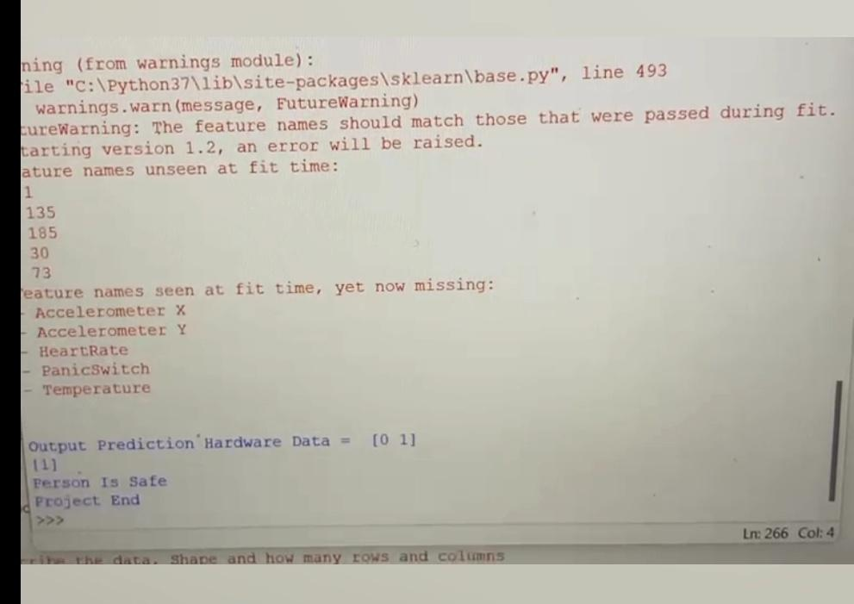

**Fig 2 (a). Output for the safe state**

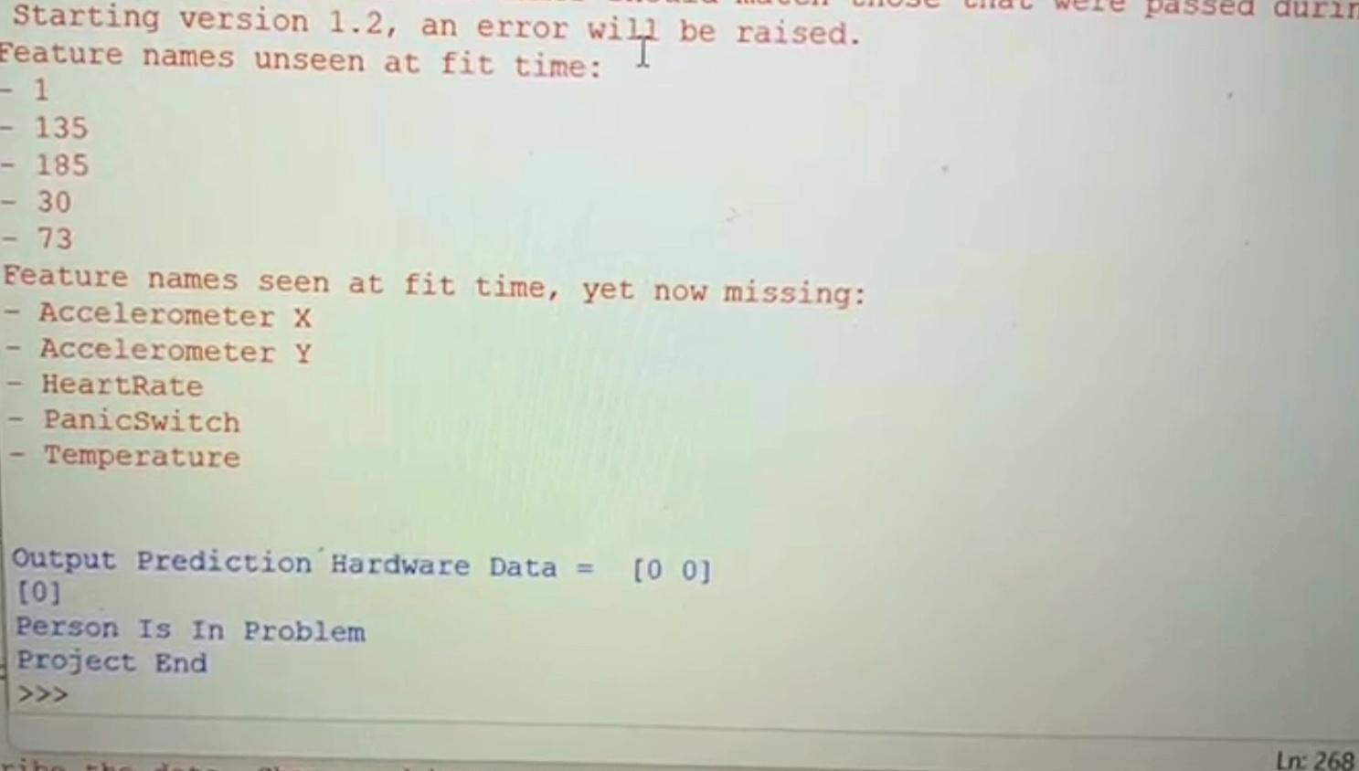

**Fig 2 (b). Output when person is in danger**

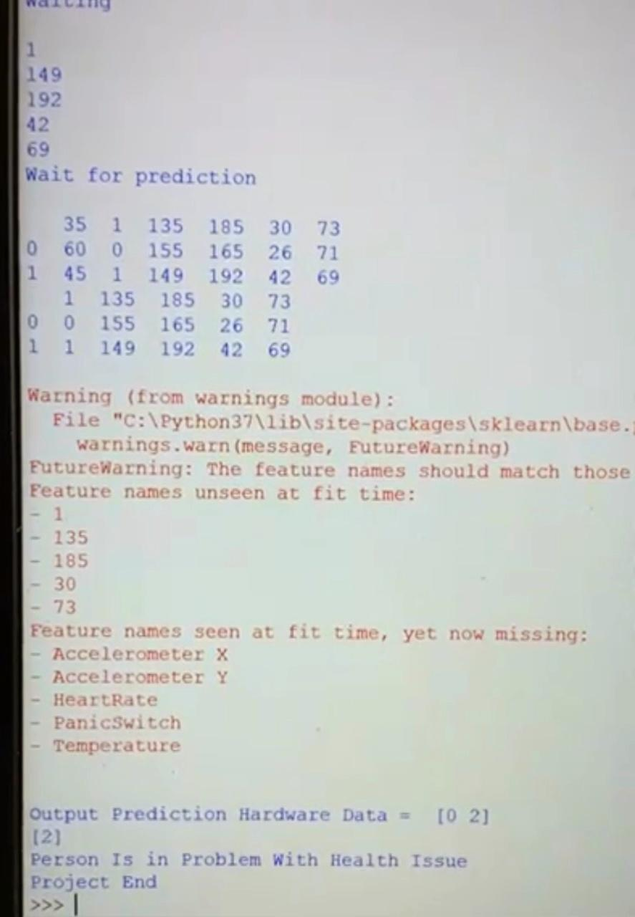

**Fig 2 (c). Output for the danger state with health problems**

## APPENDIX B: Details of publications

* + 1. **Author Names:** Abhijnya K.G, Divyakriti Masaun, Ankitha, Pallavi G.B, Latha N.R

**Paper Title:** Women safety gadget-Safety first

**Name of the Journal:** Submitted to the International Journal of Innovative Science and Research Technology.

**Date of journal:** March 2022

APPENDIX C: Details of patents NIL

APPENDIX D: Details of funding NIL

## APPENDIX E: Programme Outcomes Mapped

|  |  |  |
| --- | --- | --- |
| **PROGRAMME OUTCOMES** | **Level (1/2/3)** | **Justification if addressed** |
| **PO1** | 3 | Using embedded C programming for hardware and dumping code to microcontroller |
| **PO2** | 3 | Understanding the I/O pins and ports of microcontrollers and assembling different parts accordingly. |
| **PO3** | 2 | Architecture of IOT device and its interactions |
| **PO4** | 3 | Methods based on research were studied. |
| **PO5** | 3 | Used Python libraries and Python IDLE for running the programmes. |
| **PO6** | 1 | The project can further be extended to different areas of security and surveillance |
| **PO7** | 1 | The project does not have negative effects on environment |
| **PO8** | 1 | Measures are taken so that the project is ethical to the best of our knowledge |
| **PO9** | 3 | Every team member contributed to the project and discharged his duties well. |
| **PO10** | 3 | Published a paper. |
| **PO11** | 2 | Effectively communicated and presented results. |
| **PO12** | 3 | This project enabled us to expand our knowledge of current trends in IOT and Machine learning |
| **PSO1** | 3 | Knowledge of Microcontrollers and Machine learning |
| **PSO2** | 2 | Integrated IOT device with python prediction models using machine learning. |
| **PSO3** | 3 | Efficient code was produced to solve the problem. |

APPENDIX F: Plagiarism report